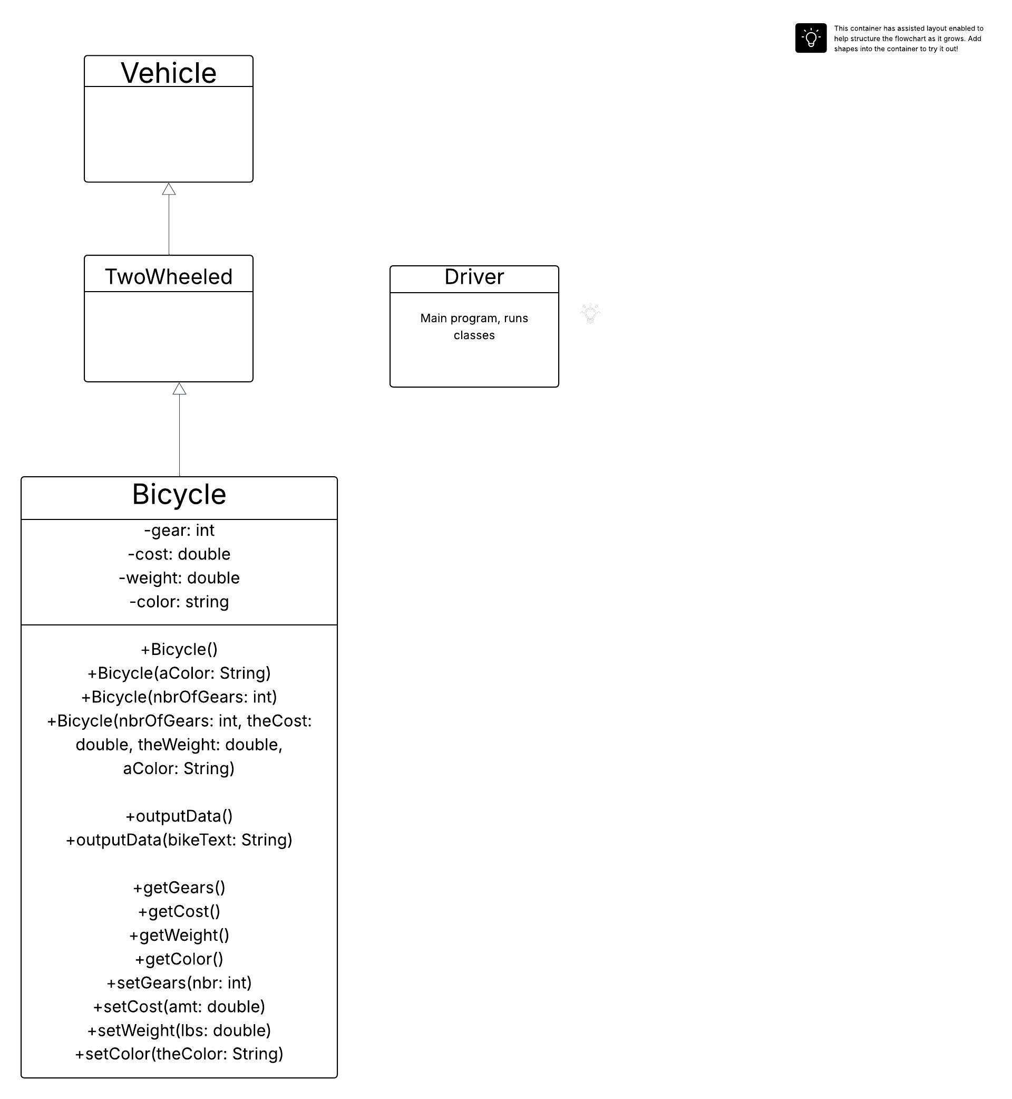
This diagram shows the 4 different classes that we have in this program, that being the Driver or main class, the Vehicle, the Twowheeled, and the Bicycle class. It shows that the vehicle class is the parent and that the TwoWheeled class inherits attributes from it. Furthermore, he see that the Bicycle class is a child of the Twowheeled class which means that it not only inherits information from the Twowheeled class but also shares similarities with the vehicle class as well. We can see that the Driver class is the main program that runs all of the features so while it is not directly related, it is the program that runs all of the features of these classes together in one place. We don’t have much information from the information in the Twowheeled class or the Vehicle class but we received a lot of information from the Bicycle class. In the top are the private variables which are specific and kept within that class. Then we have the assessors and mutators along with the output functions. These are all public so they are visible and usuable between the different classes.

